**Part 1: Uncompensated Servo Module Response**

1. The response of the uncompensated servo system in the nominal range is as follows:

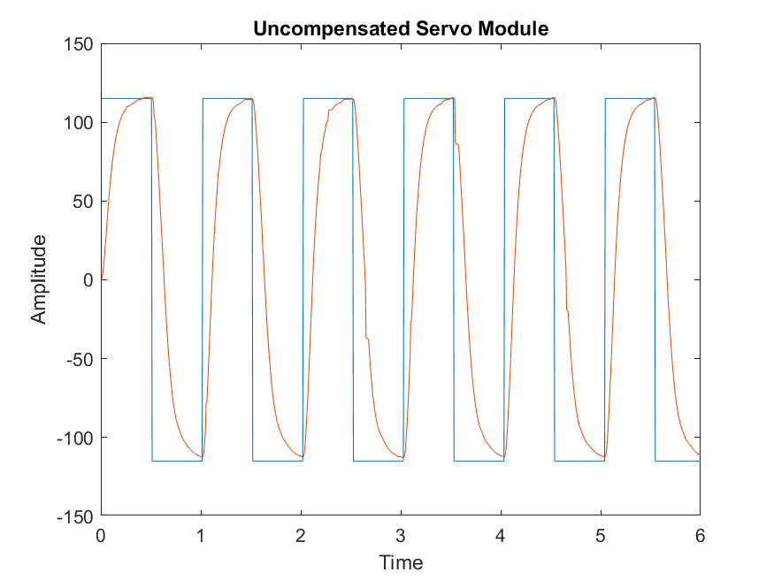 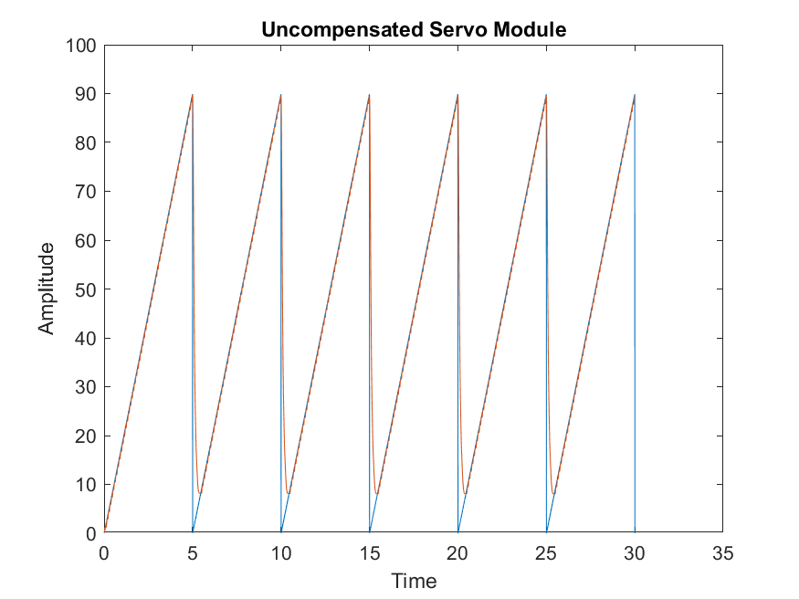

**Figure 1.1: Uncompensated Servo (Square Wave) Figure 1.2: Uncompensated Servo (Ramp)**

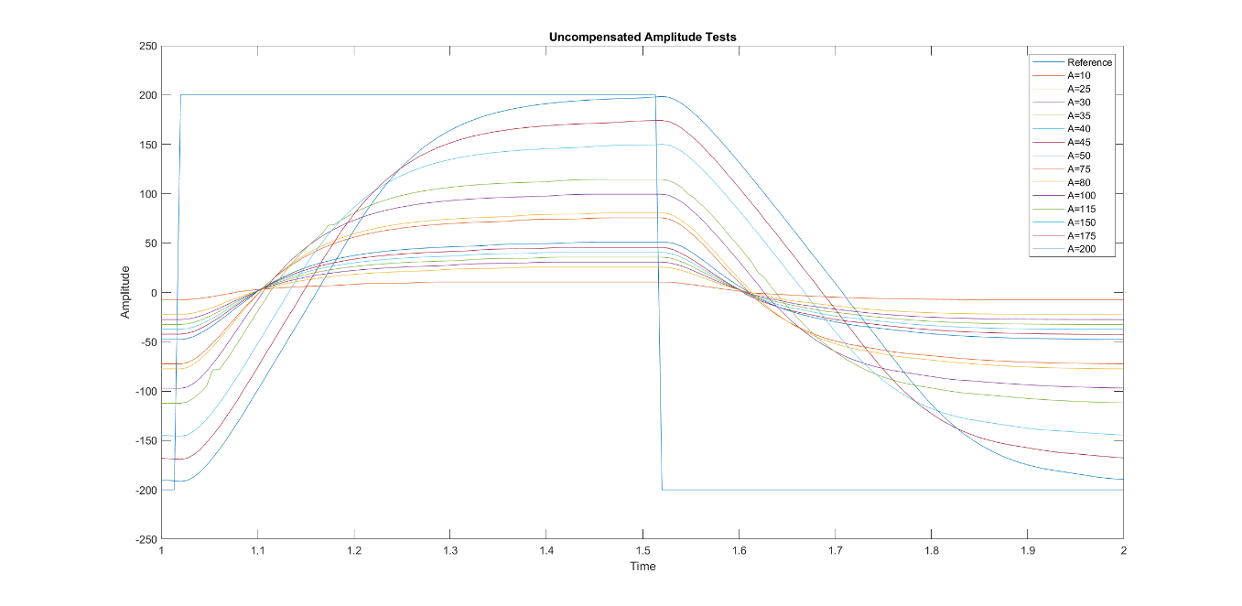

**Figure 1.3: Uncompensated Servo Amplitude Test for A = 10 to A = 200**

1. The nonlinearities present in the square wave response are evident just by observing the Figure 1.1 above. The errors are a result of only implementing a Proportional controller. However, when a PID controller is being implemented, the main proportion of control is handled by Proportional controller.
2. The nonlinearities are caused by the dead-zone effect, as it is evident just via observation. Tweaking the Kp value adjusts the effects on the system. Since a P controller is being used, gain is the only adjustable parameter and thus makes it a limiting factor towards making nonlinearity too difficult to accomplish.
3. Below is a table comparing the results achieved from both part 1 with an uncompensated as well as PID from part 2.

Table 1.1: Parameters for Uncompensated Proportional and Compensated PID Control

|  |  |  |  |  |  |
| --- | --- | --- | --- | --- | --- |
| System Type | PO (%) | Settling Time (±2%) (s) | Rise Time (10-90%) (s) | Steady State Error (Step) (%) | Steady State Error (Ramp) (%) |
| Uncompensated P Control | 0 | 0.0001 | 0.1533 | 1.1336 | ∞ |
| Compensated PID Control | 5.28 | 0.0002 | 2.2 | 1.0506 | ∞ |

1. The system type is a Type 0, as it is evident by observing the step and ramp response of the system. The steady state error of the system response backed the system type. In Type 0, the steady state error of the positional gain is always a constant value. The step and ramp response conform to the expected values for Type 0. This is corroborated by the values in Table 1.1. Also, a system Type 0 has an infinite steady state error unlike Type 1 which has a constant ramp response.